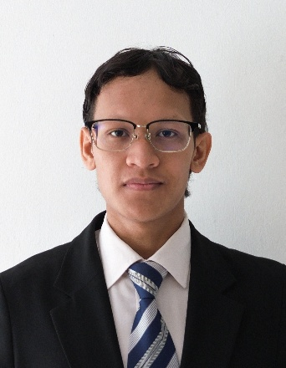

MUHAMMAD AKRAM ZAKI BIN AMRAN

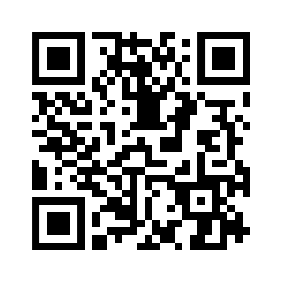

**Mobile :** +60 11-28710720

**Email :** [makramzaki.work@gmail.com](mailto:makramzaki.work@gmail.com)

**Address :** Bandar Baru Bangi, Selangor

**LinkedIn :** <https://www.linkedin.com/in/mazx28/>

**Website :** <https://resume.maztech.my/>

# SUMMARY

Dedicated Computer Science student specializing in **Information Security and Assurance** with comprehensive expertise in Software Engineering and Networking. **CompTIA Tech+ certified professional** and **MARA Scholarship recipient (2022-present)** with proven experience in implementing robust security measures and enhancing organizational cybersecurity posture. **Active cybersecurity awareness advocate** and **public speaker** who regularly participates in **Capture the Flag (CTF) competitions**, demonstrating **advanced problem-solving skills under pressure**. Proficient in **threat assessment, vulnerability management, secure coding practices, and network security administration**. Seeking employment opportunities to apply technical expertise and drive meaningful security initiatives in forward-thinking organizations.

# EDUCATION

## Universiti Sains Islam Malaysia (USIM), Nilai (2021 – Present)

Bachelor of Computer Science (Hons.) in Information Security and Assurance

## Universiti Sains Islam Malaysia (USIM), Nilai (2020 – 2021)

Foundation in Science and Technology

# LEADERSHIP EXPERIENCE

* Designed the task for the competition AturKreatif’25 Capture the Flag (CTF) under ISAC. **(2025)**
* Bureau of Publicity and multimedia, USIM Debate Club 21/22, 22/23 and 23/24 session. **(2021 – 2024)**
* Deputy Director, Global Islamic Student Outreach (GISO): Discovering the Insights of Culture Tadabbur Alam di Bumi Vietnam. **(2024)**
* Leader of Publicity and multimedia, Global Islamic Student Outreach (GISO): Mencari Ibrah di Selatan Thailand. **(2024)**
* Leader of Safety Unit, Global Islamic Student Outreach (GISO): Ilm and Ihsan in Formosa: Empowering Knowledge and Excellence, Taiwan. **(2024)**
  + - * Speaker in sharing sessions with students from Asia Eastern University of Science and Technology, Taiwan.
* Mentor & Judge, HackINSAN, Universiti Sains Islam Malaysia (USIM). **(2024)**
* Second Vice President, Student Secretariat of The Faculty of Science and Technology, SekreFaST 22/23 session, (USIM). **(2022 – 2023)**
  + - * Deputy Director, Faculty of Science and Technology (MAFaST) Awards Ceremony. **(2022)**
      * Director, Crew & Friends Appreciation Ceremony. **(2022)**

# ACHIEVEMENT

* **Second runner-up** in UTAR Intervarsity Capture the Flag (CTF). **(2024)**
* **Champion** in Microsoft AI for Accessibility Hackathon under **Microsoft. (2024)**
* **Champion** in Capture the Flag (CTF) under AturKreatif’24 USIM **(2024)**
* Received the **Dean’s List Award** for the 6th semester. **(2024)**
* **Finalist** in Capture the Flag Inter– Universities’23 under Petronas. **(2023)**
* Awarded as **Top 4** in Curtin University Capture the Flag (CTF) **(2023)**
* Awarded as **Top 4** in iTREXC Capture the Flag (CTF) Universiti Islam Selangor. **(2023)**
* **Silver Award,** Mechasonic Iris Project, Malaysia Invention and Innovation Expo **(2023)**
* **Silver Award,** Virtual Reality Gamification, Muamalat Interactive Game, Digital Innovation Creative Entrepreneurship (DICE’23). **(2023)**
* **Gold Award,** Mechasonic Iris Project, ASEAN Innovative Science Environmental and Entrepreneur Fair. **(2023)**
* Participated in ‘UMHack’ Hackathon Competition and created a website Artificial Intelligence (AI) based. **(2023)**
* **Second runner-up** in Capture the Flag (CTF) AturKreatif Universiti Sains Islam Malaysia. **(2022)**
* Received the **Dean’s List Award** for the 2nd semester. **(2022)**

# WORKING EXPERIENCES

## Willowglen Malaysia Sdn Bhd (Feb 2025 – Present)

**Project Software & Solution Trainee**

* + Designed and implemented automated systems to streamline operational workflows, reducing manual workload and improving organizational efficiency.
  + Conducted vulnerability assessments and provided strategic remediation recommendations with detailed risk analysis and business impact justifications.

# CERTIFICATES

## CompTIA Tech+ (August 2025)

## Python Programming Fundamentals (Jun 2025)

# SKILLS

## Technical Skills:

* + - **Software & Tools:** Microsoft Office (Advanced), VS Code, Eclipse, GitHub, XAMPP
    - **Programming**: HTML, PHP, Java, C, C++, C#, Python, MySQL
    - **Operating Systems**: Windows, Ubuntu, Kali Linux, Parrot OS
    - **Cybersecurity Tools**: Ghidra, JADX, Nmap, Burp Suite, Wireshark, Metasploit

## Soft skills:

* + - **Communication**: Public speaking, technical writing, cross-cultural communication
    - **Leadership & Management**: Team leadership, project coordination, mentorship
    - **Problem-Solving:** Critical thinking, strategic planning, innovation
    - **Collaboration:** Cross-functional teamwork, international cooperation
    - **Adaptability:** Rapid learning, tech adaptation, cultural flexibility
    - **Time Management:** Event planning, multitasking, academic–extracurricular balance
    - **Initiative:** Self-driven, proactive, committed to continuous growth
  + **Languages**: Malay **(Native)**, English **(Full Professional Proficiency)** and Arabic **(Limited Working Proficiency).**

# REFERENCES

**Prof Madya Dr. Sakinah binti Ali Pitchay**

Professor Madya Lecturer DS54

Faculty of Science and Technology (FST) Universiti Sains Islam Malaysia (USIM) [sakinah.ali@usim.edu.my](mailto:sakinah.ali@usim.edu.my)

**Norjannah Hazali**

Senior Software Quality Assurance

Willowglen Malaysia Sdn Bhd

[jannah@willowglen.com.my](mailto:jannah@willowglen.com.my)

**Mr. Shaharudin Ismail**

Senior Lecturer DS52

Faculty of Science and Technology (FST)

Universiti Sains Islam Malaysia (USIM)

[shaharudin@usim.edu.my](mailto:shaharudin@usim.edu.my)